**Project Design Phase-II**

**Data Flow Diagram & User Stories**

|  |  |
| --- | --- |
| Date | 31 January 2025 |
| Team ID | LTVIP2025TMID31055 |
| Project Name | ToyCraft Tales: Tableau's Vision into Toy Manufacturer Data |
| Maximum Marks | 4 Marks |

**Data Flow Diagrams:**

A Data Flow Diagram (DFD) is a traditional visual representation of the information flows within a system. A neat and clear DFD can depict the right amount of the system requirement graphically. It shows how data enters and leaves the system, what changes the information, and where data is stored.

**DFD:**

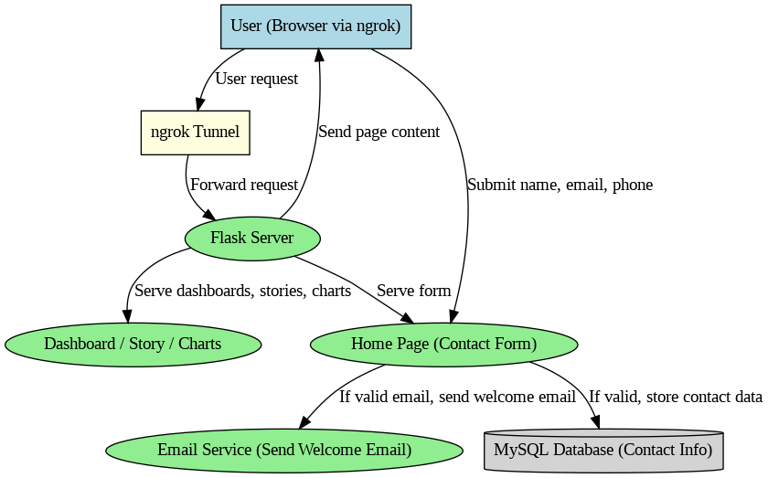

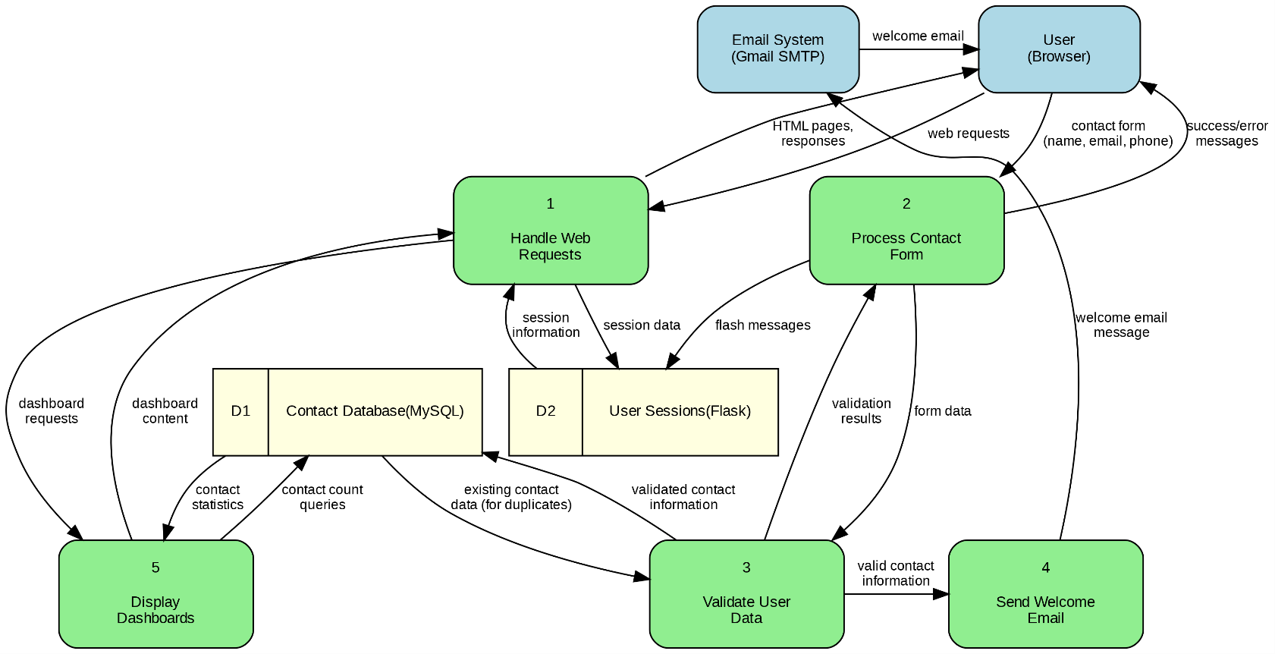

**User Stories**

Use the below template to list all the user stories for the product.

| **User Type** | **Functional Requirement (Epic)** | **User Story Number** | **User Story / Task** | **Acceptance criteria** | **Priority** | **Release** |
| --- | --- | --- | --- | --- | --- | --- |
| Customer (Mobile user)/(web user) | Registration / Contact Form | USN-1 | As a user, I can access the application via ngrok and view the Home, Dashboard, Story, and Charts options. | I can access my account / I can see and navigate between these options when the server is running. | High | Sprint-1 |
|  |  | USN-2 | As a user, I can fill in my name, email, and phone number in the contact form to join the committee. | I can submit my details successfully to the server. | High | Sprint-1 |
|  |  | USN-3 | As a user, if I submit a valid email, I will receive a welcome email from ToyCraft Tales. | I can receive a welcome email at my valid email address after form submission. | Medium | Sprint-1 |
|  |  | USN-4 | As a user, I As a user, if I submit an invalid email, no email will be sent, and my data will not be saved. Register for the application through Gmail | I can see that no email is sent and no data is saved when the email is invalid. | Medium | Sprint-1 |
|  | Dashboard | USN-5 | As a user, I can access the interactive dashboard from the menu and view visual insights. | I can view and interact with the dashboard (filters, tooltips, etc.). | High | Sprint-1 |
|  |  | USN-6 | As a user, I can apply filters on the dashboard (e.g., by year, manufacturer, state) to refine the data view. | I can see the dashboard update dynamically based on the filters I apply. | Medium | Sprint-2 |
|  | Charts | USN-7 | As a user, I can access individual charts showing analyses such as Toy Manufacturers by Year or Top 10 States. | I can view the charts without errors and see relevant data visualizations. | High | Sprint-1 |
|  |  | USN-8 | As a user, I can interact with chart elements (e.g., hover or click for details). | I can see detailed information when I hover over or click on chart elements. | Low | Sprint-2 |
|  | Story | USN-9 | As a user, I can access a Tableau story with multiple scenes showing toy industry trends. | I can navigate between story scenes without errors. | High | Sprint-1 |
|  |  | USN-10 | As a user, I can navigate between story scenes and understand key insights from each scene. | I can see a clear title and summary of insights in each story scene. | Medium | Sprint-2 |
| Customer Care Executive |  | USN-11 | As a customer care executive, I can view contact form submissions stored in the MySQL database. | I can access a secure view of stored contact data. | Medium | Sprint-2 |
| Administrator |  | USN-12 | As an admin, I can manage (view, edit, delete) contact form submissions in the database. | I can update or delete records of contact submissions as needed. | High | Sprint-1 |
|  |  | USN-13 | As an admin, I can monitor the availability of the server (Flask + ngrok status). | I can view or be alerted when the server is down or unreachable. | Medium | Sprint-2 |